Lab Report for Module 4 Dropbox

Lab: Some Day You Have to Get Organized

Submitted by: Tristan Izlar

1. 8 Points
2. 12.7 GB

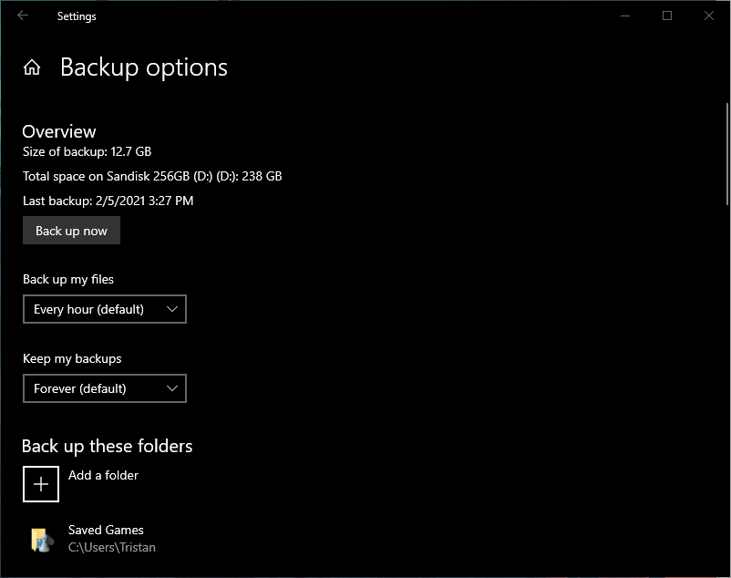

1. 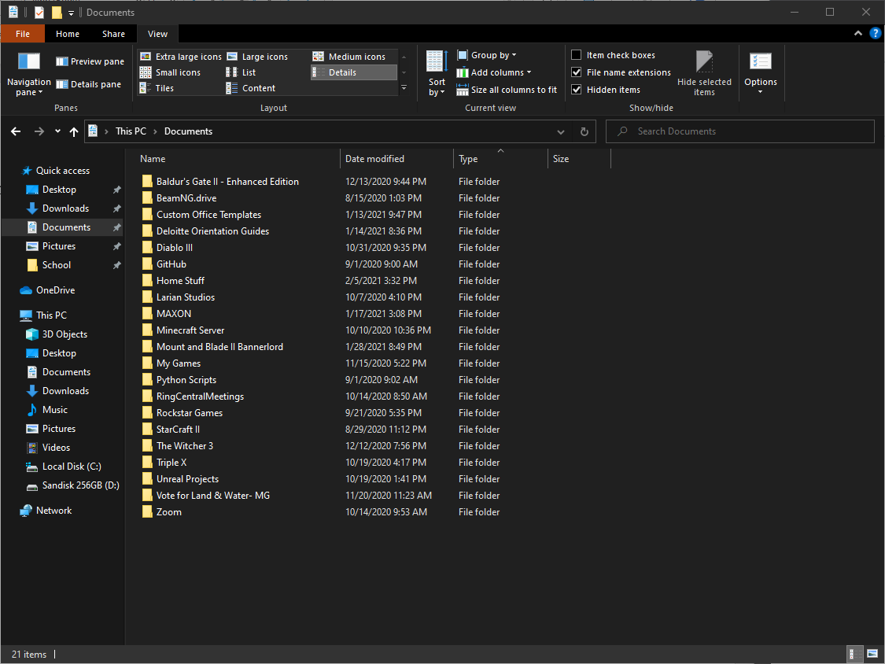
2. 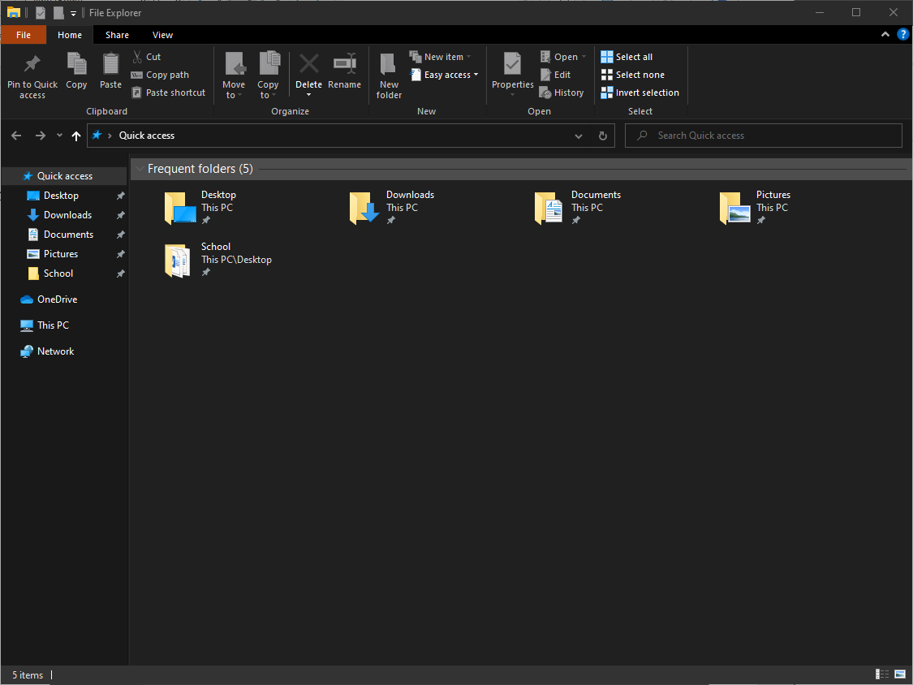
3. 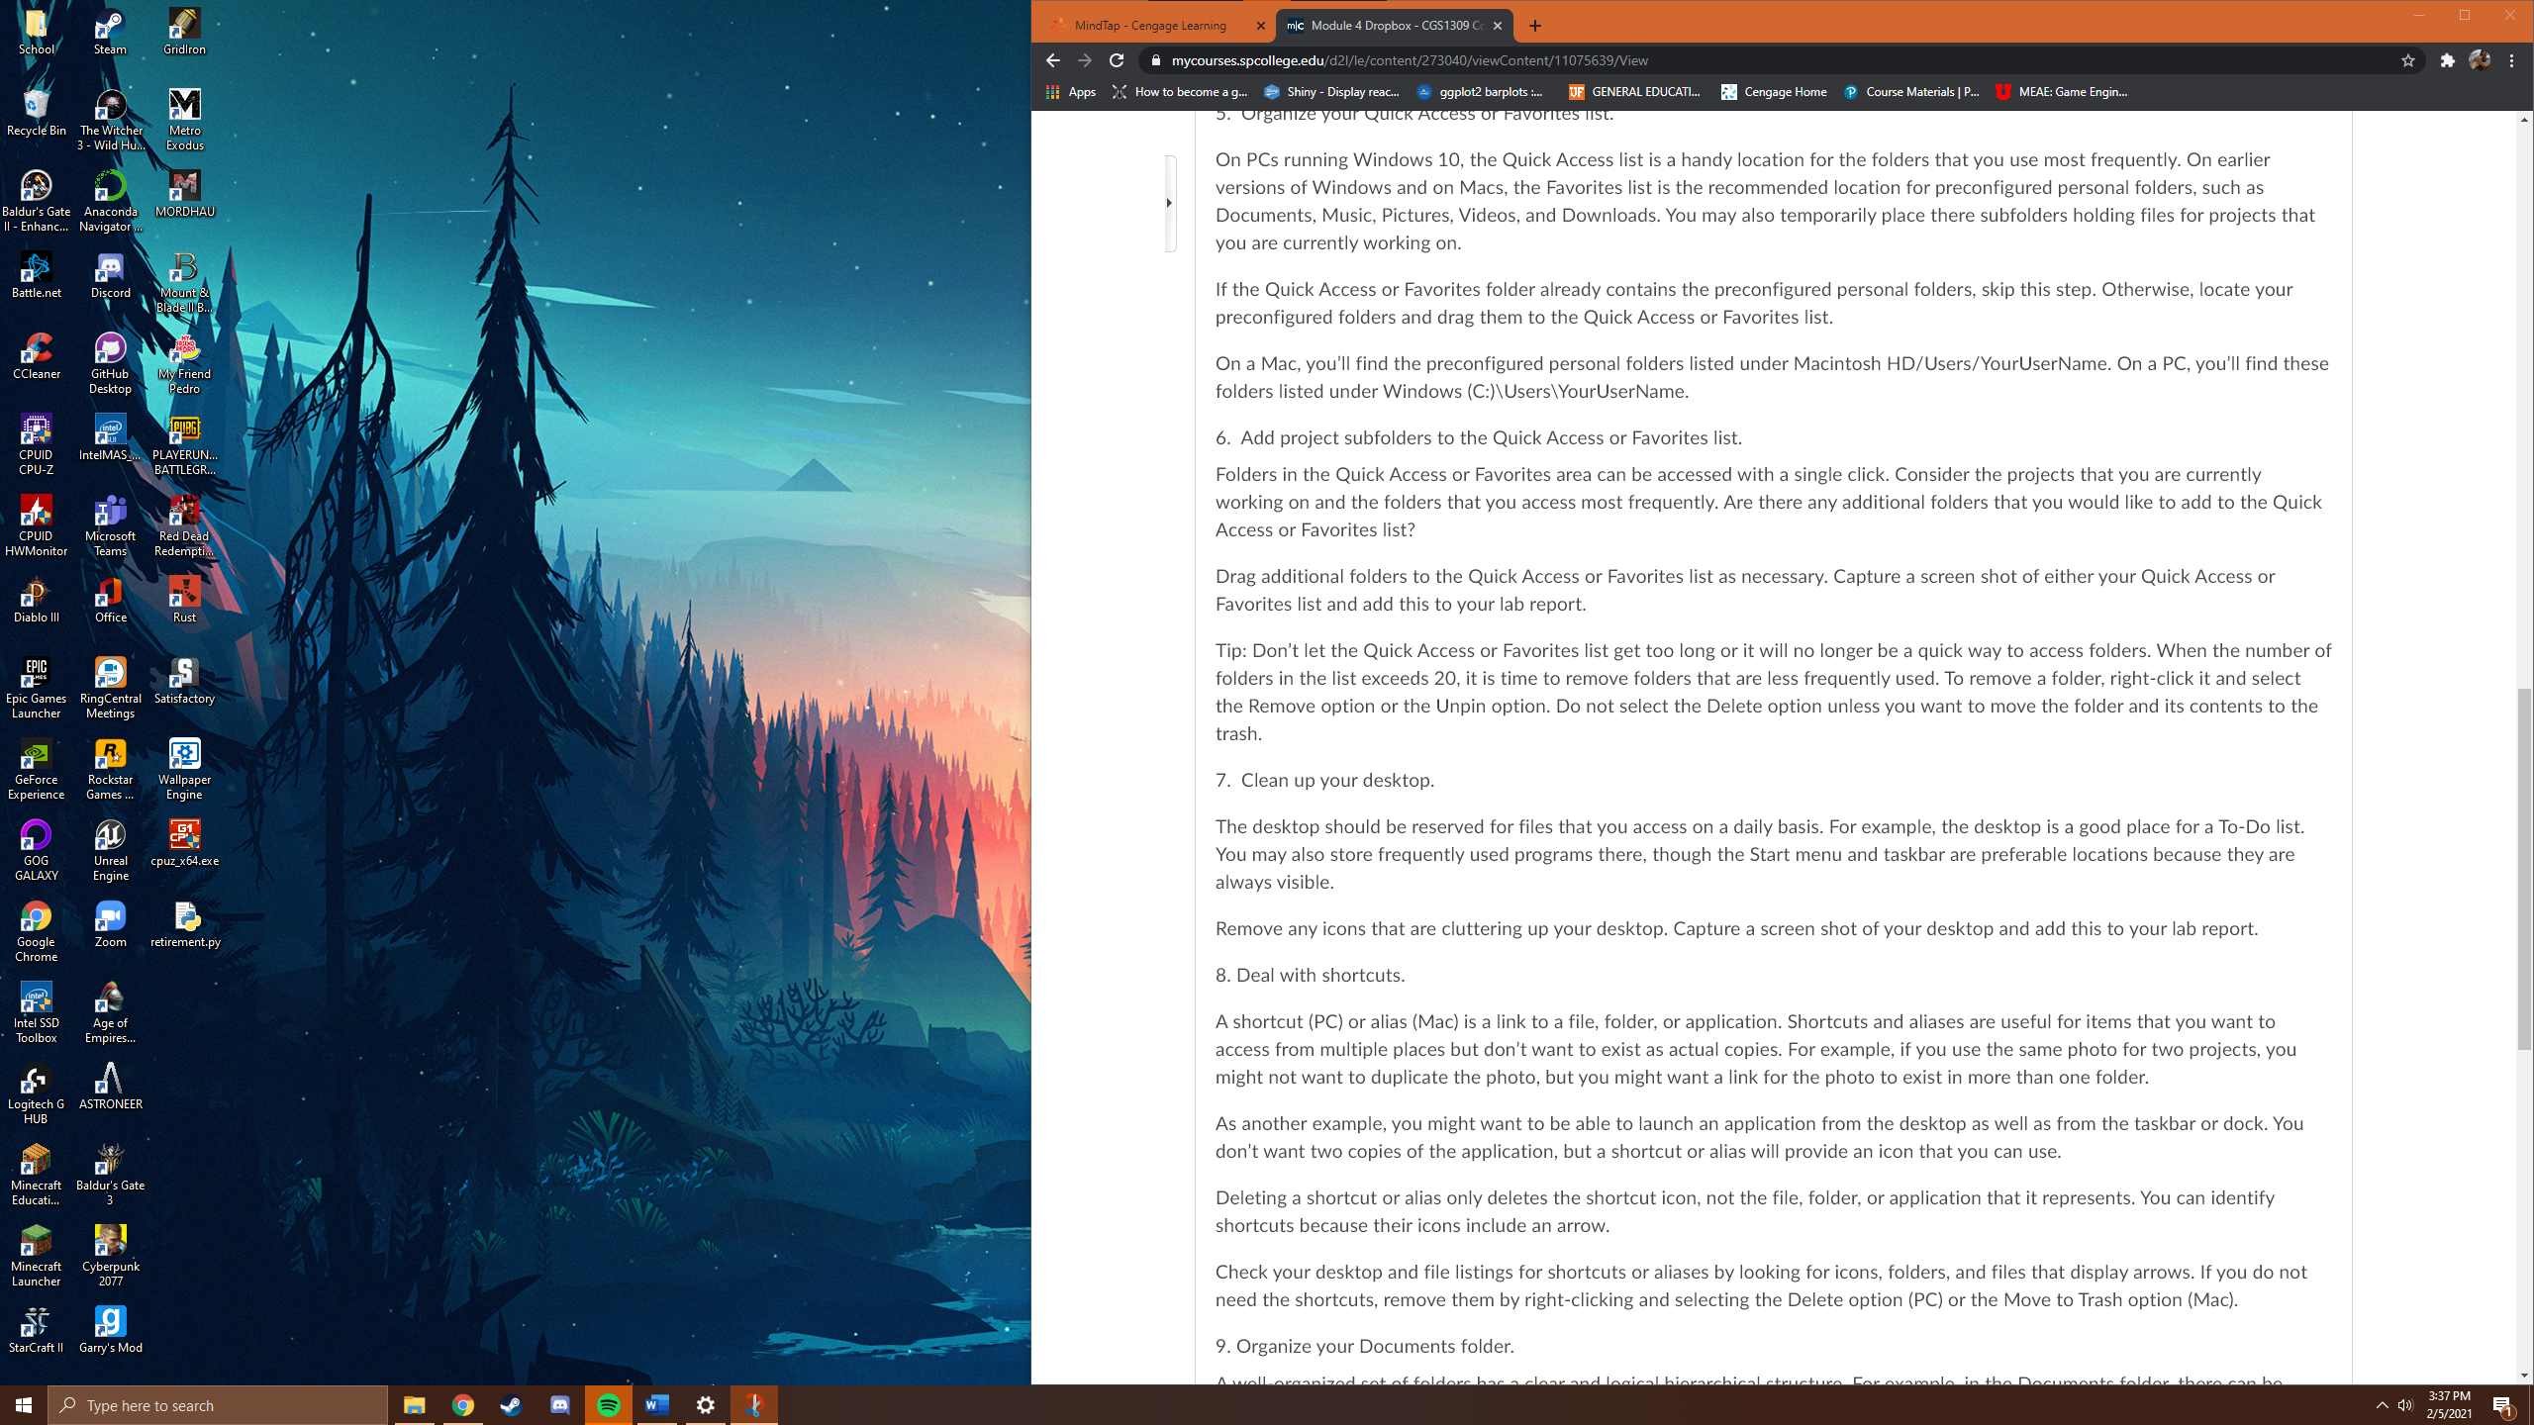
4. 